(a) (b)
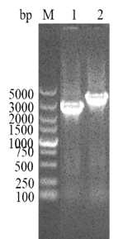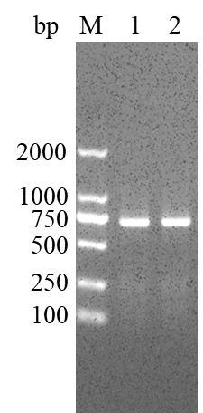
(c) (d)
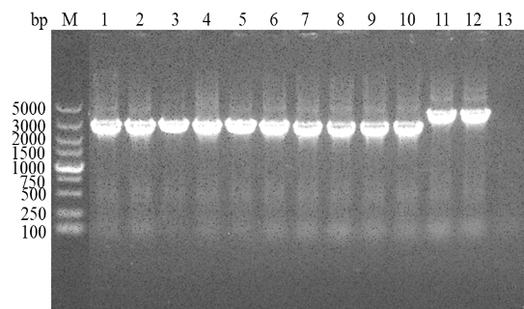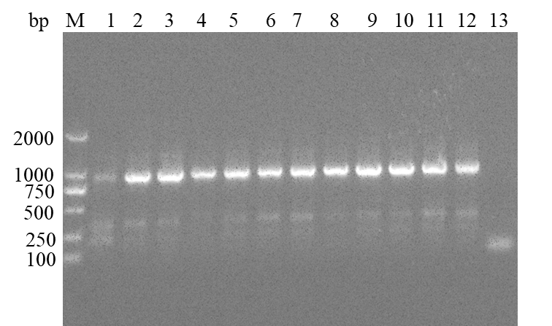

Fig. S1 Confirmation of the success and genetic stability of mutant strain ∆dotU and complemented strain C-dotU. (a) PCR detection of the mutant strain ∆dotU, M: DL5000 Marker; 1: the mutant strain ∆dotU; 2: wild type TH0426. (b) PCR detection of the complemented strain C-dotU, M: DL2000 Marker; 1: C-dotU; 2: TH0426. (c) Genetic stability of the partial deletion strain ∆dotU, M: DL5000 Marker; 1-10: ∆dotU; 11-12: TH0426; 13: control group. (d) Genetic stability of the partial complemented strain C-dotU, M: DL2000 Marker; 1-10: C-dotU; 11-12: TH0426; 13: control group.

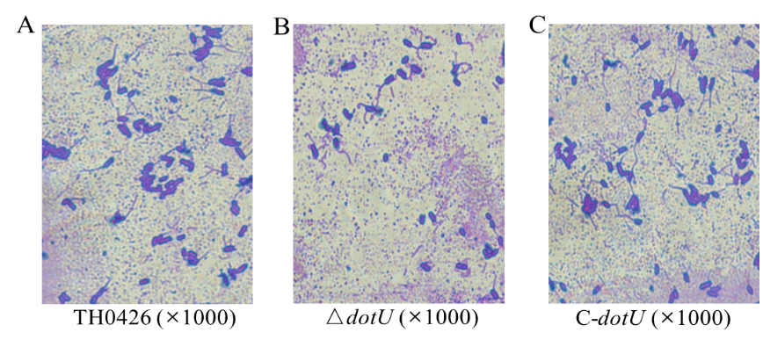

Fig. S2 Flagellum straining and light microscopy observation of the three strains (the wild-type, ∆dotU and C-dotU). Light microscopy images of parental strain (A), ∆dotU (B) and C-dotU (C). Magnifications, 1000 × (A, B and C).

